**Mobile Guides**

[**https://www.figma.com/file/327iVSJunIVuYyc0cvjWgZ/UIUX_Dhania-Eka-Sofie?node-id=48%3A1000**](https://www.figma.com/file/327iVSJunIVuYyc0cvjWgZ/UIUX_Dhania-Eka-Sofie?node-id=48%3A1000)

**Dropdown**

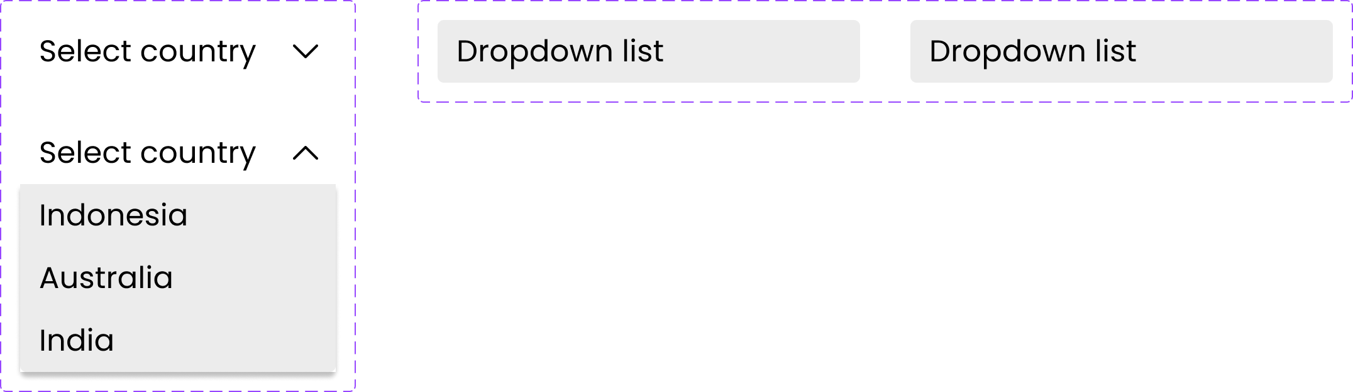

**Tooltip**

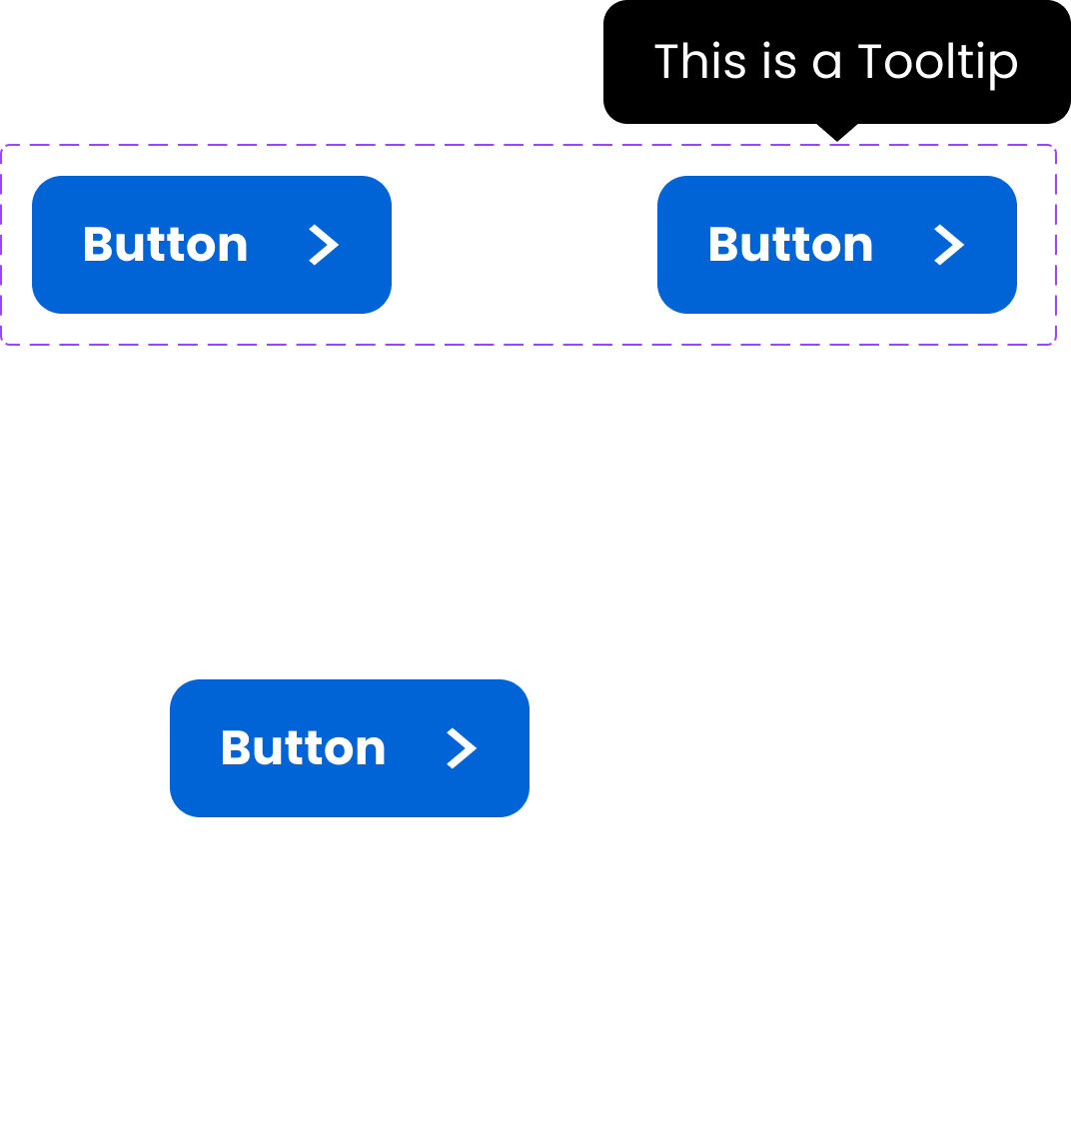

**Check Box & Radio Button**

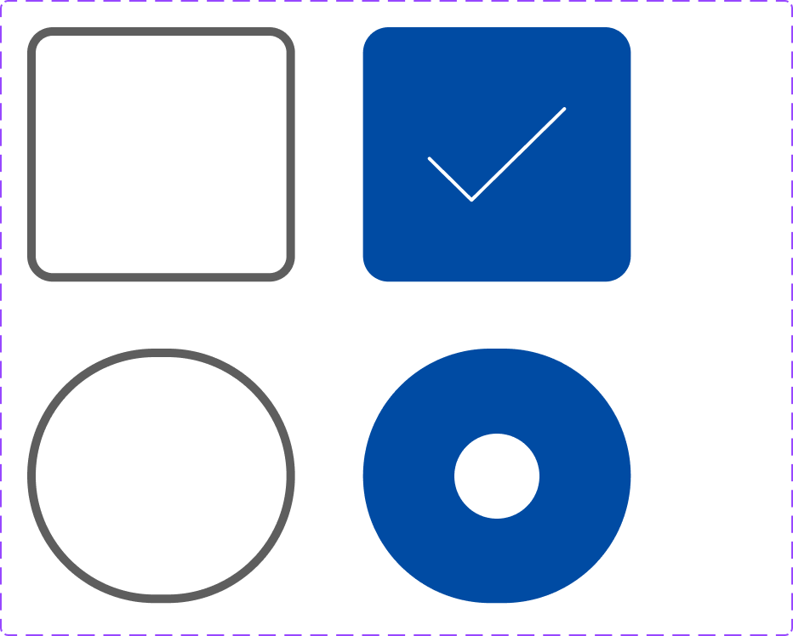

**Snack Bar**

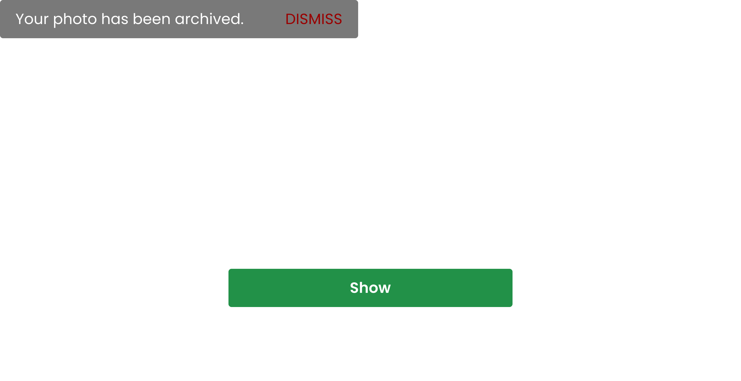

**Toggle**

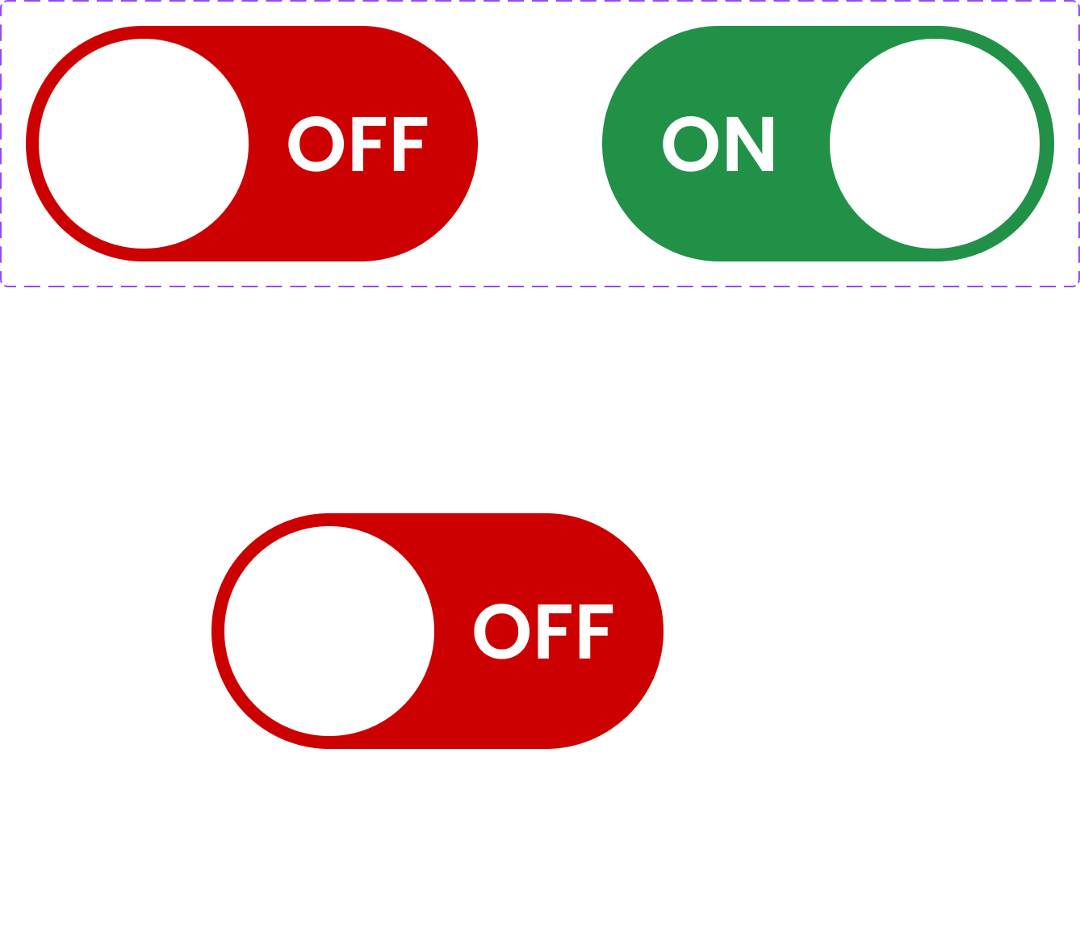

**Tab Bar**

